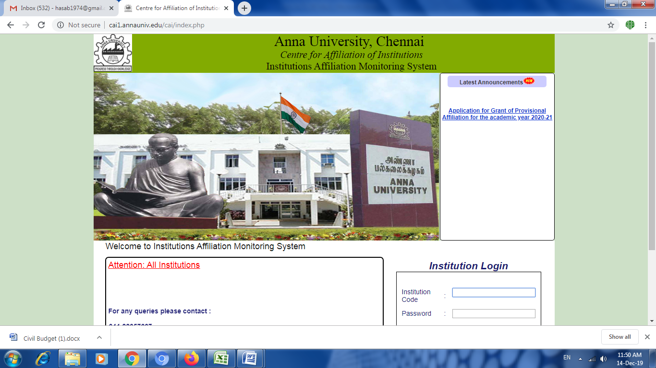
DEPARTMENT | ELECTRICAL AND ELECTRONICS ENGINEERING
NAME OF THE COURSE | B.E(EEE)
TITLE (Mr / Mrs /Dr.) | DR.T.POOMPAVAI
REGULAR / ADJUNCTION | REGULAR
PRESENT DESIGNATION | ASSISTANT PROFESSOR
RESIDENTIAL ADDRESS (No, STREET & AREA) | 38/33 Andiyappa Achari street, Kamatchiammanpet, Gudiyatham
CITY & PINCODE | Vellore - 632602
DISTRICT | VELLORE
TELEPHONE No. ( If any) | 04171222126
MOBILE No. | 8124449650
EMAIL | paavai.oct@gmail.com
GENDER | FEMALE
COMMUNITY (OC, BC, MBC, SC,ST & OTHERS) | BC
PAN No. * | DJKPP1665L
AADHAAR No. * | 247183639070
FACULTY CODE GIVEN BY COE | 5119266
FACULTY CODE GIVEN BY AICTE (Optional) | 43354052163
DATE OF BIRTH | 08/10/1989
AGE | 35
SCALE OF PAY | 15600-45000
PRESENT BASIC PAY | 18000
TOTAL EMOLUMENTS | 45000

EDUCATIONAL QUALIFICATION
CATEGORY: UG/PG/Ph.D., | DEGREE | SPECIALIZATION | YEAR OF PASSING | NAME OF THE COLLEGE | NAME OF THE UNIVERSITY | % OF MARKS OBTAINED | CLASS OBTAINED
U.G. | B.E | Electrical and Electronics Engineering | 2011 | Arunai Engineering College | ANNA UNIVERSITY | 70 | FIRST
P.G. | M.Tech | Power Electronics and Drives | 2013 | VIT University  Vellore Campus | VIT University | 7.76 | FIRST
Ph.D | Ph.D | Electrical Engineering | 2022 | VIT University  Vellore Campus | VIT University | - | FIRST

ADDITIONAL QUALIFICATION
GATE( IN CASE OF B.E / B.Tech)
NET ( INCASE OF MCA/M.Sc.,/M.A)
SLET ( INCASE OF MCA/M.Sc.,/M.A)
SCORE ( Submit a Xerox copy for proof)

TITLE OF Ph.D THESIS | Investigation of Swarm Intelligence Based Maximum Power Point Tracking Algorithm and Power Management Strategy for Standalone Solar Photovoltaic Water Pumping System with Energy Storage
FACULTY IN WHICH PhD., WAS AWARDED | Electrical Engineering

ACADEMIC EXPERIENCE
(From the latest)
COLLEGE | DESIGNATION | JOING DATE | RELIEVING DATE | EXPERIENCE
 |  |  |  | YEARS | MONTHS | DAYS
 | Assistant Professor | 01-03-2023 | 07-07-2025 | 2 | 4 | 6
  Priyadarshini Engineering College
G.K.M College of Engineering and Technology | Assistant Professor | 03-01-2022 | 31-12-2022 | 0 | 11 | 9
VIT University |  | 01-12-2017 | 29/11/2019 | 1 | 11 | 28
  Teaching cum Research Assistant
 | Assistant Professor | 05-01-2015 | 30-06-2016 | 1 | 5 | 25
  Vedantha Institute of Technology
 | Assistant Professor | 01-01-2014 | 31-12-2014 | 1 | 0 | 0
  Kingston Engineering College,
TOTAL |  |  |  | 5 | 31 | 68
INDUSTRIAL EXPERIENCE
NAME OF THE ORGANIZATION | DESIGNATION | NATURE OF WORK | JOING DATE | RELIEVING DATE | EXPERIENCE
 |  |  |  |  | YEARS | MONTHS | DAYS
 | TOTAL

C.O.E. APPOINTMENT EXPERIENCE
(CAPACITY ATWHICH SERVICE IS EXTENDED FOR THE CONDUCT OF EXAMIANTION DURING THE LAST YEAR)
AUR  (No. of days) | SQUAD MEMBER  (No. of days) | EXTERNAL EXAMINER  (PRACTICAL)  (No. of days) | CENTRAL VALUATION  (No. of Scripts) | REVALUATION  (No. of Scripts)

